LOSEINI KAMARA
Rockwall, TX 75087 | Public Trust (DoD, 2020–2021) | linkedin.com/in/loseinikamara | valotechnologiellc.com
NETWORK SECURITY LEADER | SENIOR PALO ALTO & CISCO ENGINEER
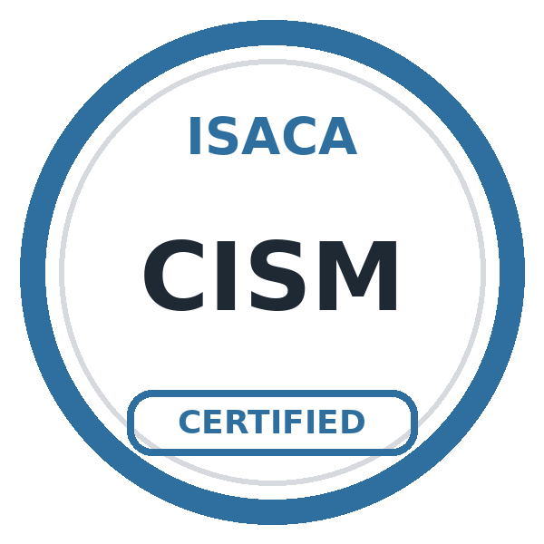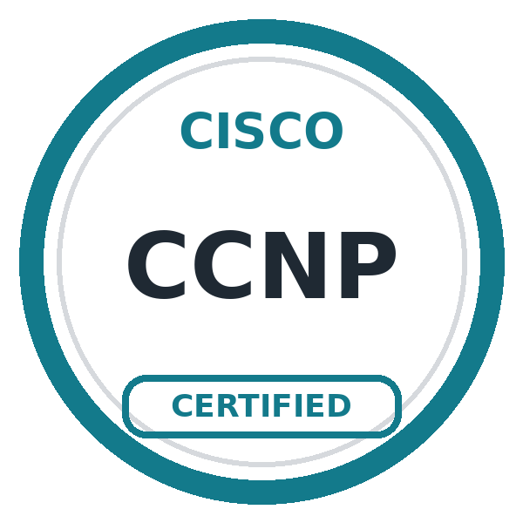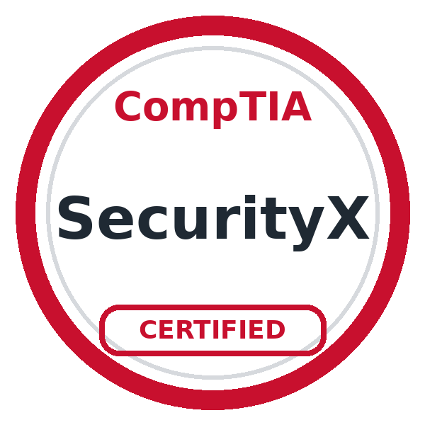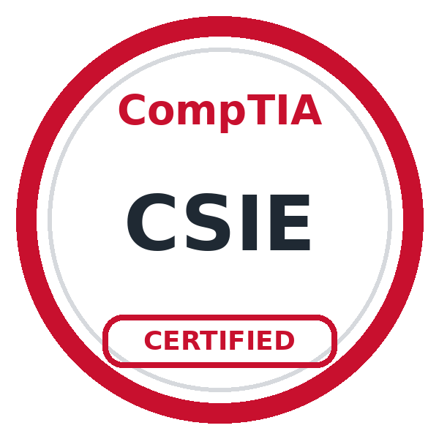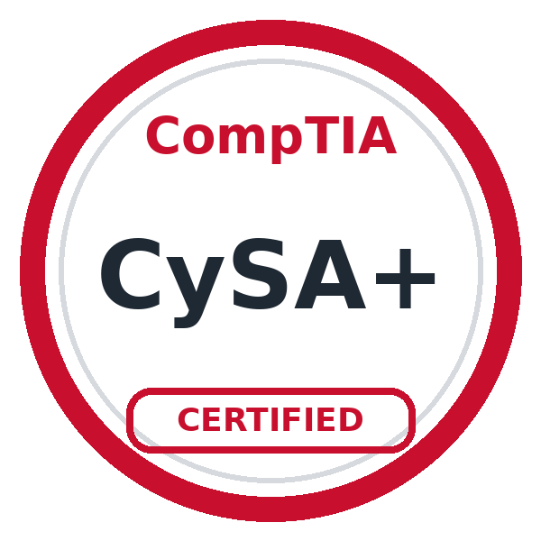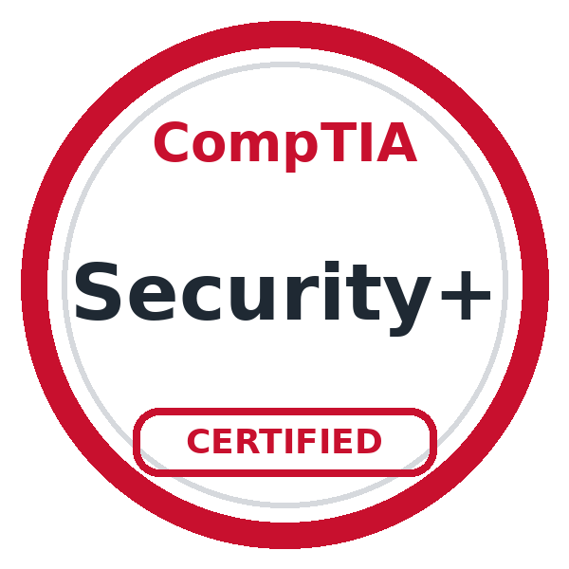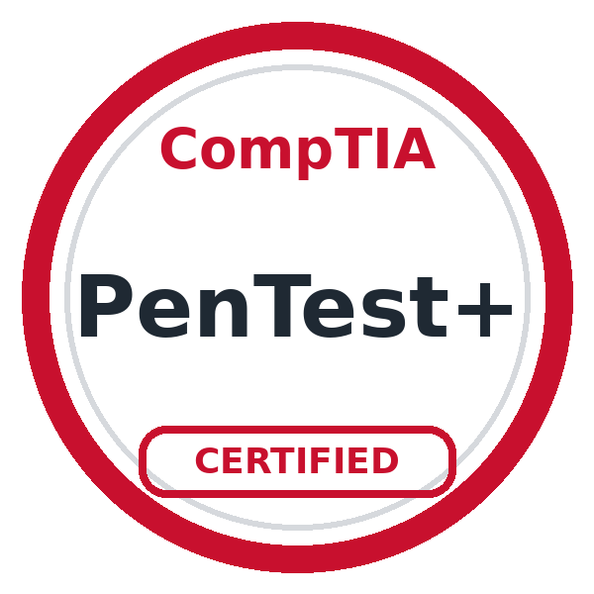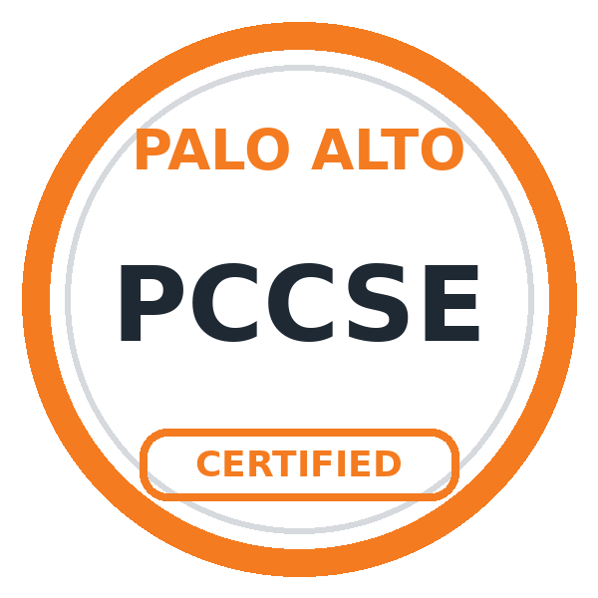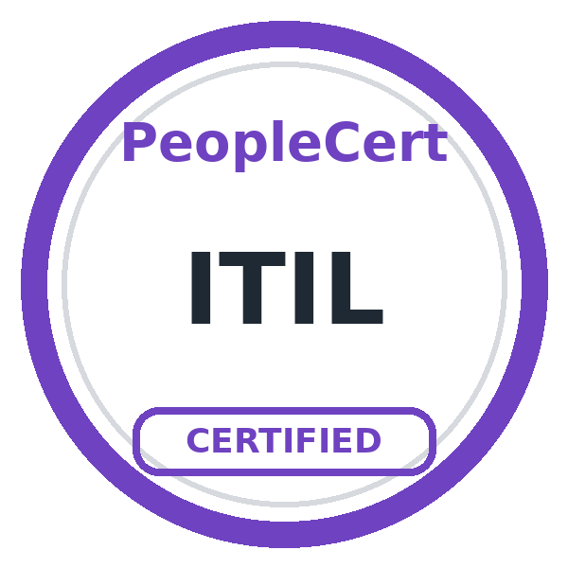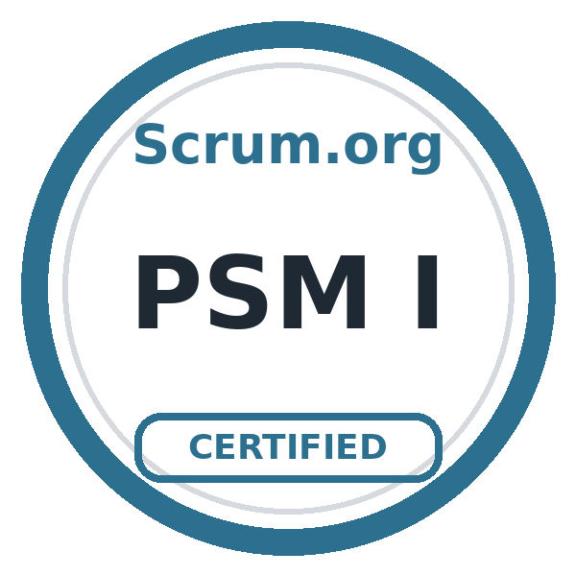
SPECIALTIES: Palo Alto NGFW & Panorama / GlobalProtect VPN / Prisma Access / Firewall Migrations & Modernization / Firewall Rulebase Cleanup / Network Segmentation / Zero Trust / Cisco Routing, Switching & ISE / Day-to-Day Network & Firewall Operations / Change Management / NAT, Security Zones & Routing / SSL/TLS & PKI / AWS Cloud Security / SD-WAN / Threat Prevention & URL Filtering / Terraform, Ansible & Python / HIPAA & NIST Frameworks
PROFESSIONAL SUMMARY
- Network security leader and senior engineer with 9+ years in network and security engineering, including 6+ years hands-on with Palo Alto firewalls, across government, DoD military healthcare, healthcare, and regulated environments. Most recently managed 71 Palo Alto NGFWs through Panorama at Dallas County and led county-wide firewall, Cisco core, and Cisco ISE initiatives.
- Owns changes end to end, from scope and risk through change controls, change windows, rollback plans, validation, and handover. Runs day-to-day enterprise network and firewall operations and coordinates infrastructure, security, IAM, and vendor teams around one plan. Founder of VALO Technologies, delivering Palo Alto and Cisco engineering to MSPs, SMBs, and SLED organizations.
CORE TECHNICAL SKILLS
Palo Alto Security: Palo Alto NGFW, Panorama, GlobalProtect, Prisma Access, WildFire, Cortex XDR, App-ID, Threat Prevention, URL Filtering, Security Profiles, Firewall Policy Management
Security Architecture: Enterprise Firewall Architecture, Network Security Design, Zero Trust Architecture, Network Segmentation, Security Standards, Risk Remediation, Secure Remote Access, Security Assessments
VPN & Connectivity: GlobalProtect VPN, Remote Access VPN, Cisco ASA VPN, VPN Migration Support, Secure Connectivity Solutions, VPN Troubleshooting
PKI & Security Services: Public Key Infrastructure (PKI), SSL/TLS Technologies, Certificate-Based Communications, Authentication Technologies, AWS Security Services
Networking: TCP/IP, BGP, OSPF, EIGRP, MPLS, VLANs, Cisco Routing & Switching, SD-WAN, Cisco ISE, Infoblox DNS/DHCP/IPAM
Cloud & Automation: AWS, VPC, Security Groups, WAF, Transit Gateway, Terraform, Ansible, Python
Compliance & Frameworks: HIPAA, NIST 800-53, NIST CSF, CJIS, ISO 27001, CIS Benchmarks
Monitoring & Leadership: Splunk, Microsoft Sentinel, Rapid7, Technical Leadership, Change Management, Vendor Management, Technical Documentation

CERTIFICATIONS
- CISM | Palo Alto PCCSE | CCNP Enterprise | SecurityX (CASP+) | CSIE | CySA+ | Security+ CE | PenTest+ | ITIL | PSM I
Palo Alto Training: EDU-210 Firewall Essentials | EDU-220 Panorama | EDU-330 Firewall Troubleshooting
EDUCATION
- Master of Science (M.S.), Cybersecurity and Information Assurance | Western Governors University | February 2025
- Master of Business Administration (MBA), Information Technology Management | Western Governors University | November 2022
- Bachelor of Science (B.S.), Cybersecurity and Information Assurance | Western Governors University | August 2020

PROFESSIONAL EXPERIENCE
VALO Technologies LLC
Founder & Principal Consultant (Self-employed)
Apr 2023 – Present
- Founder of a network security engineering firm delivering senior Cisco and Palo Alto Networks expertise to MSPs, SMBs, and SLED organizations.
- Installed and configured Palo Alto firewalls for small and midsize businesses: security zones, NAT, VPN, GlobalProtect remote access, and URL filtering.
- Installed and configured Cisco switches for SMB client networks.
- Run business development, scoping, and delivery end to end: discovery, proposals, implementation, documentation, and handover.
- Cisco Registered Partner and Palo Alto Networks NextWave Registered Reseller (via Ingram Micro); SAM.gov registered (CAGE 0QMV2, UEI ZWY2EB1Q75C4).

Dallas County, TX
Senior Network Security Engineer (Full-time)
Sep 2025 – Oct 2026
- Managed 71 Palo Alto NGFWs through Panorama: centralized policy deployment, monitoring, troubleshooting, and operational support.
- Ran day-to-day enterprise network and firewall operations: change requests, monitoring, incident response, troubleshooting, and user and site connectivity issues.
- Created change controls for every change, with documented implementation, validation, and rollback plans.
- Led firewall upgrades, migrations, policy reviews, and lifecycle maintenance.
- Led a county-wide Cisco Catalyst core modernization with structured testing, rollback, and validation.
- Led county-wide Cisco ISE upgrades and NAC policy optimization.
- Remediated 175 Palo Alto firewall rules to least privilege.
- Designed secure WLAN architecture for 10,000+ users.
- Designed and implemented network segmentation for secure access to enterprise applications.
- Configured and maintained security policies, NAT, GlobalProtect, URL filtering, threat prevention, routing, and security zones.
- Resolved complex connectivity and security issues using PAN-OS logs, packet analysis, and root-cause analysis.
- Partnered with Security, Infrastructure, and IAM teams on Zero Trust initiatives; coordinated external vendors and service providers on connectivity projects.
- Developed technical documentation, operational procedures, architecture diagrams, and security standards.
Environment: Palo Alto NGFW, Panorama, GlobalProtect, Cisco Catalyst, Cisco ISE, Network Segmentation, NAT, Routing, Security Zones

Apex Systems | Client: Paragon Healthcare (Elevance Health)
Senior Security Engineer | Palo Alto Network Security (Contract)
Oct 2024 – May 2025
- Handled day-to-day Palo Alto firewall operations: rule and access requests, policy changes, monitoring, troubleshooting, and incident investigation.
- Administered GlobalProtect and Prisma Access supporting secure remote access for the workforce; managed External Dynamic Lists.
- Processed changes through change control with documented implementation, validation, and rollback steps.
- Supported Palo Alto firewall modernization, including migration from legacy firewalls to Palo Alto NGFW.
- Reviewed and remediated firewall rules to enforce least privilege, retiring obsolete and inactive rules to reduce attack surface.
- Monitored and responded to security incidents using Splunk and Microsoft Sentinel; blocked malicious URLs, IPs, and other indicators of compromise.
- Worked with infrastructure, security, compliance, and operations teams on HIPAA-aligned security controls.
Environment: Palo Alto NGFW, Panorama, GlobalProtect, Prisma Access, Splunk, Microsoft Sentinel, HIPAA

Dallas County, TX | via Catapult Solutions Group
Senior Network Security Engineer (Contract)
Jan 2024 – Oct 2024
- Handled day-to-day Palo Alto firewall and Panorama operations across multiple environments: policy and access requests, monitoring, troubleshooting, and incident response.
- Created change controls for every change, with documented implementation, validation, and rollback plans.
- Configured firewall policies, NAT, routing, and VPN connectivity (IPSec, SSL VPN, GlobalProtect).
- Led remediation of vulnerabilities identified in enterprise security assessments.
- Conducted firewall rule reviews, segmentation assessments, and Zero Trust readiness work.
- Evaluated Azure network security configurations and recommended improvements for cloud workloads.
- Implemented logging and threat-intelligence capabilities to improve visibility into malicious activity.
- Performed advanced troubleshooting, root-cause analysis, log reviews, and firewall optimization.
- Developed network security standards, operational procedures, and technical documentation.

Freddie Mac (Plano, TX) | via Hexaware Technologies
Network Engineer (Contract)
May 2023 – Sep 2023
- Handled day-to-day enterprise LAN/WAN operations: Layer 2/Layer 3 connectivity, routing, switching, VLANs, and network availability troubleshooting.
- Worked with Palo Alto Networks NGFWs to review security policies, analyze traffic flows, and troubleshoot application access issues.
- Processed firewall access requests, security rule changes, and NAT connectivity checks through established change control procedures.
- Diagnosed network incidents using interface status, routing tables, ping/traceroute, and firewall traffic logs to isolate connectivity problems.
- Maintained network documentation and collaborated with infrastructure and security teams on incident resolution and configuration updates.

Texas Health and Human Services | via Texcelvision
Network Security Engineer (Contract)
Nov 2021 – Mar 2023
- Handled day-to-day Palo Alto firewall operations for a statewide health agency: policy and access requests, monitoring, troubleshooting, and incident investigation.
- Created change controls for every change, with documented implementation, validation, and rollback plans.
- Administered Palo Alto firewall policies, NAT, URL filtering, and VPN services; performed PAN-OS upgrades.
- Supported GlobalProtect and secure remote access (IPSec, SSL VPN).
- Managed Infoblox DNS, DHCP, and IPAM, and AWS VPC security controls.
- Implemented network segmentation and endpoint security controls to reduce lateral movement.
- Investigated network security incidents, performed root-cause analysis, and implemented corrective actions.
- Maintained operational procedures, change records, and technical documentation.

Brooke Army Medical Center (DoD) | via 22nd Century Technologies
IT Security Engineer (Contract)
Feb 2020 – Sep 2021
- Handled day-to-day Palo Alto firewall administration in a DoD military healthcare environment: reviewed traffic and threat logs, created and modified security rules, and applied firewall updates.
- Created change controls for every change, with documented implementation, validation, and rollback plans.
- Conducted cybersecurity risk and vulnerability assessments of systems and applications and recommended safeguards.
- Assessed system security configurations and controls against DoD, HIPAA, and NIST requirements.
- Identified, documented, and supported remediation of security violations and control deficiencies.
- Developed and maintained information assurance standards, policies, procedures, and security documentation. Held Public Trust.

ADDITIONAL NETWORK EXPERIENCE
Experian (via Yochana IT Solutions) | Network Administrator | Aug 2019 – Feb 2020
• Administered Cisco Layer 2 infrastructure: VLANs, switch ports, and connectivity; handled incidents and service requests in ServiceNow.
Nissan Motor Corporation (via Pomeroy) | Senior Network Administrator | Jan 2019 – Jun 2019
• Led end-user device migrations to extended VLANs; configured DHCP reservations; supported Cisco ACS authentication; handled incidents in Remedy.
Compucom (via Onin Staffing) | Network Administrator | Aug 2017 – Jun 2018
• Configured VLANs across access, distribution, and core switching; supported DMZ, VPN, ACLs, port security, and wireless access points.

